**MapReduce program to calculate the total units sold in each state for Onida company**

**Sample input file:**

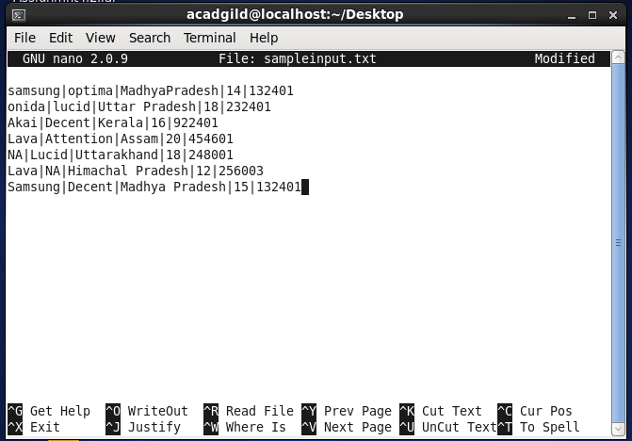

**Driver class:**

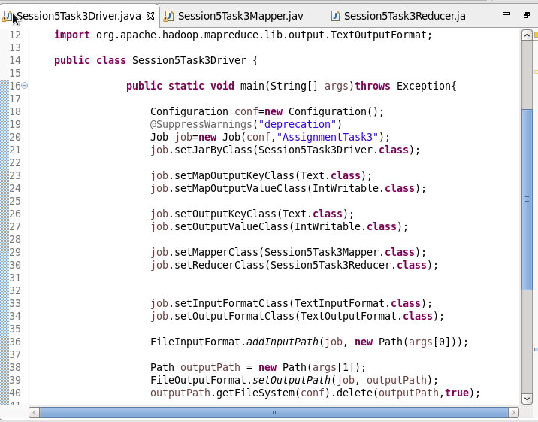

**Mapper class:**

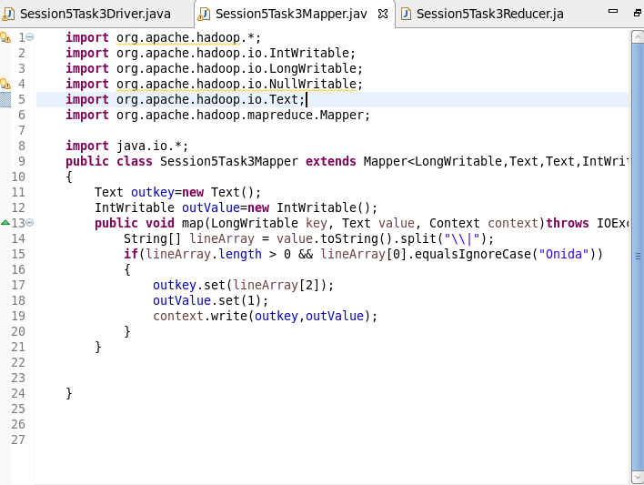

**Reducer:**

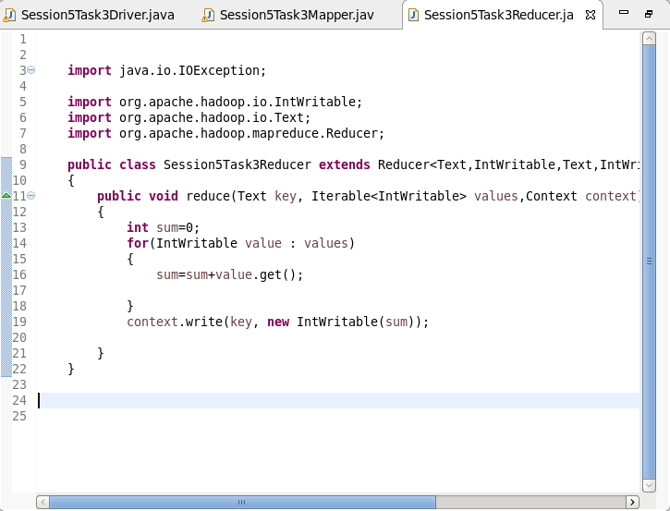

**Output:**

